**Name: Kanak Agrawal**

**Email:** [**Kanakagrawal2001@gmail.com**](mailto:Kanakagrawal2001@gmail.com)

**Date: 16-02-2024**

**Day-20 Assignment(Azure)**

**Hand Written Notes**

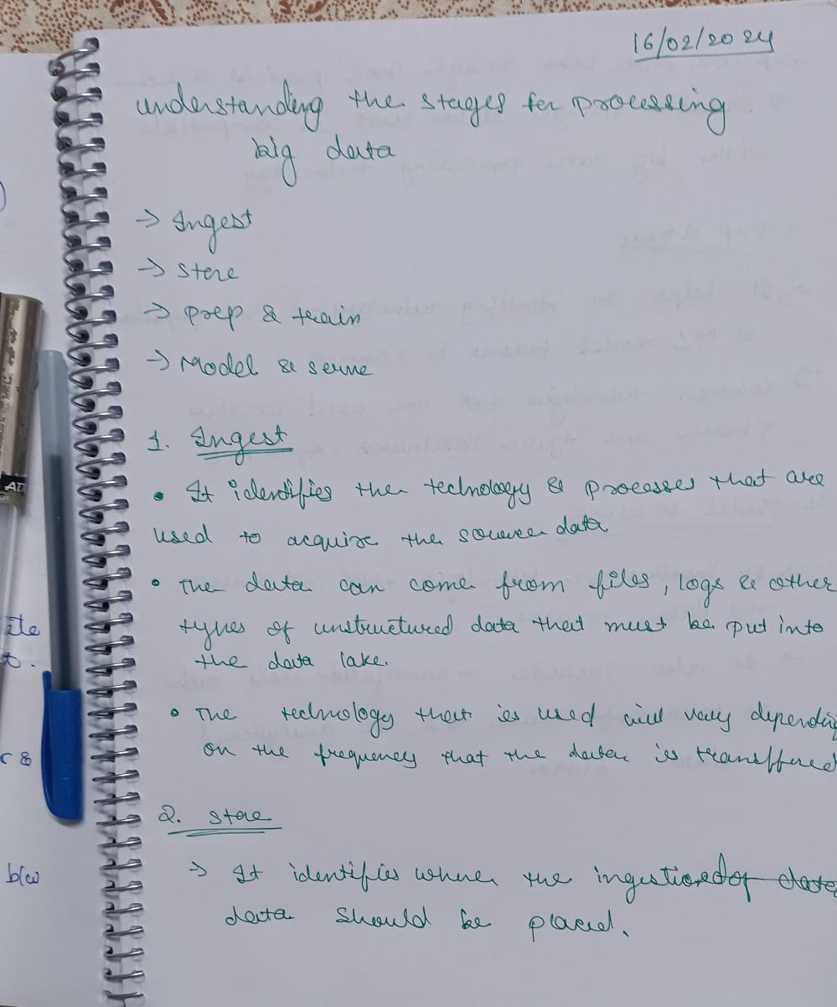

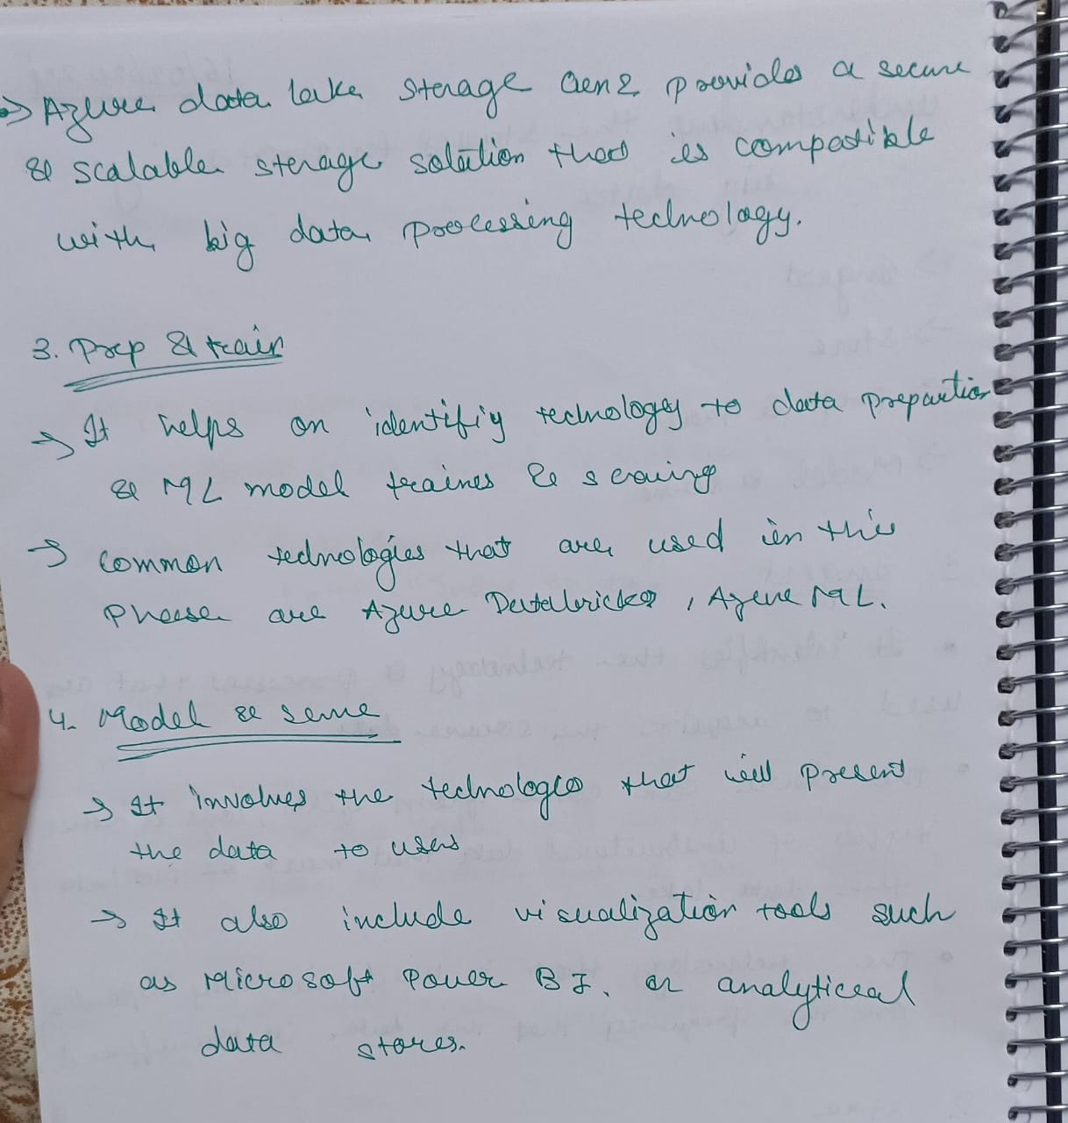

**Creating a adls gen 2 Storage account**

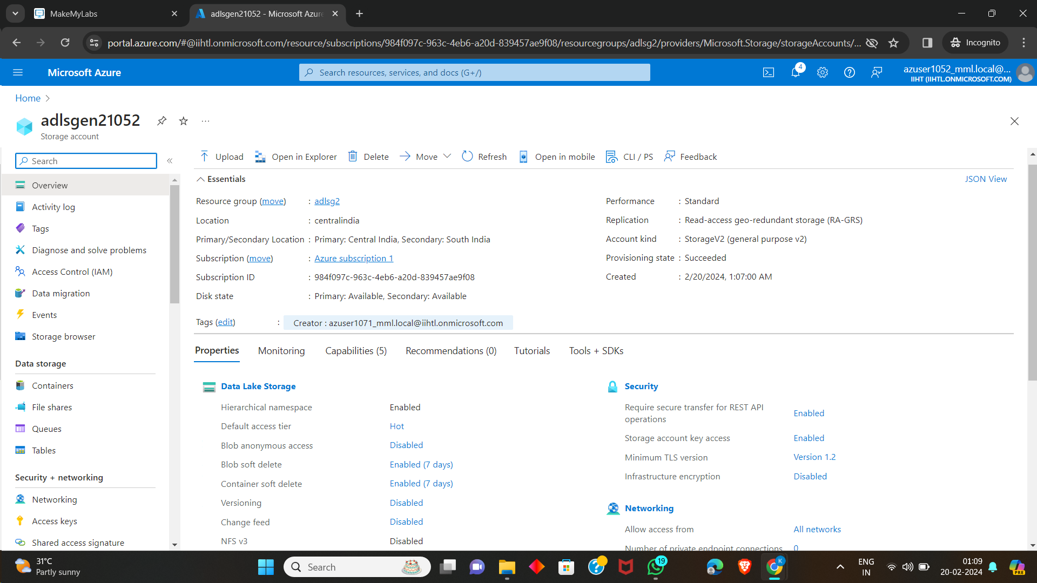

Adding a Container

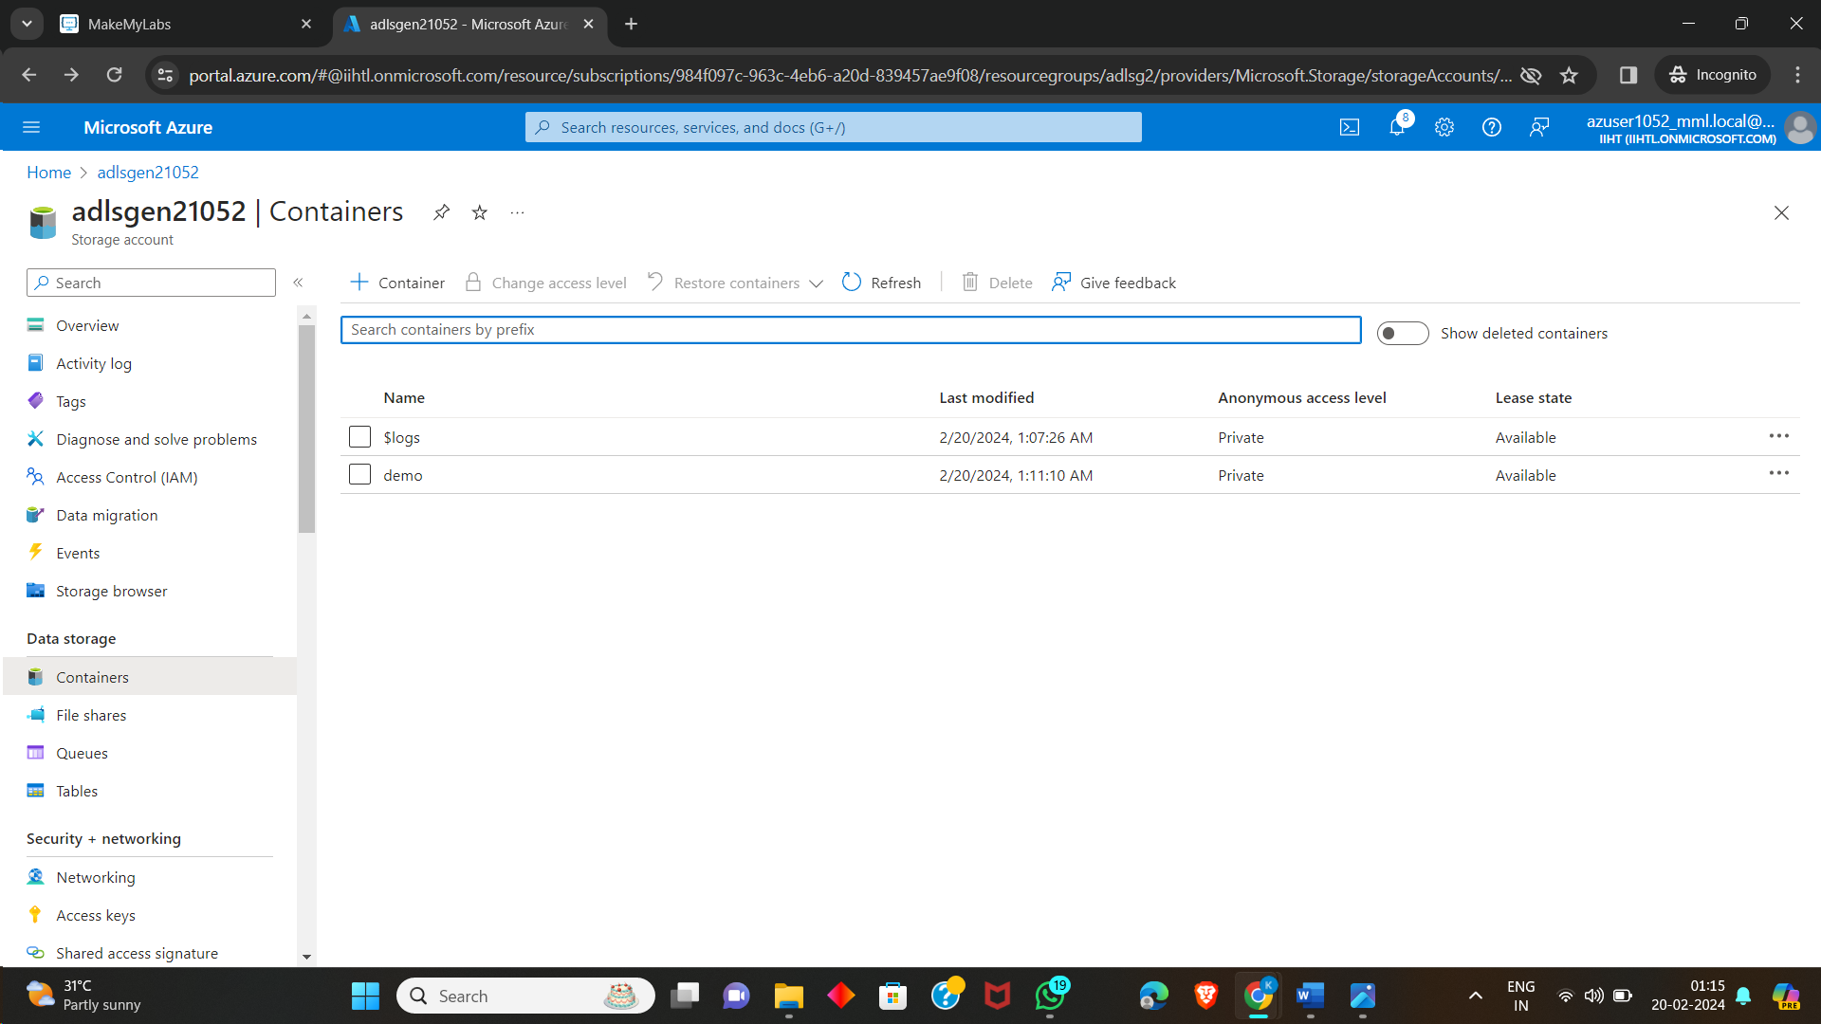

Adding a directory

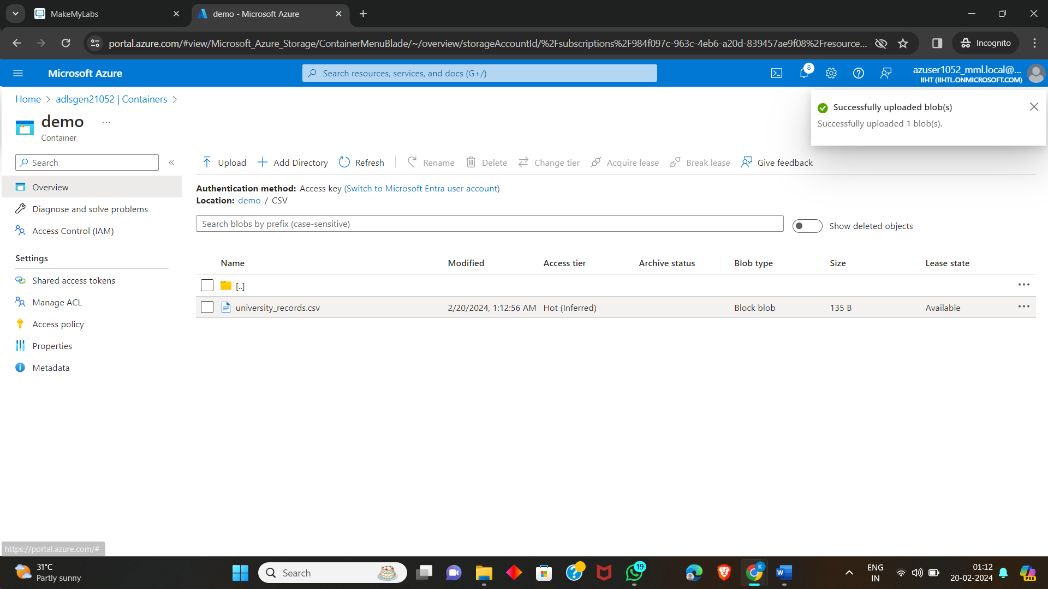

Opening a directory

